**Pizza SALES SQL Queries**

**KPI’s**

**1. Total Revenue:**

**SELECT SUM(total_price) AS Total_Revenue FROM pizza_sales;**

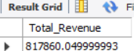

**2. Average Order Value**

**select sum(total_price)/count(distinct order_id) as Average_Order_Values**

**from pizza_sales;**



**3. Total Pizzas Sold**

**select sum(quantity) as Total_pizzas_sold from pizza_Sales;**



**4. Total Orders**

**SELECT COUNT(DISTINCT order_id) AS Total_Orders FROM pizza_sales**

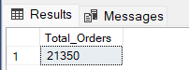

**5. Average Pizzas Per Order**

**SELECT CAST(CAST(SUM(quantity) AS DECIMAL(10,2)) /**

**CAST(COUNT(DISTINCT order_id) AS DECIMAL(10,2)) AS DECIMAL(10,2))**

**AS Avg_Pizzas_per_order**

**FROM pizza_sales**

**Whenever you are using an aggregate function with a column (order_date), u need to use group by with categorical field(order_date)**

**DW- Day of week (Saturday,mon,tue)**

**To convert order_Date to day of week**

**B. Daily Trend for Total Orders**

**\*Use the STR_TO_DATE function to convert the order_date column into a valid DATE format**

**UPDATE pizza_sales**

**SET order_date = STR_TO_DATE(order_date, '%d-%m-%Y');**

**ALTER TABLE pizza_sales MODIFY order_date DATE;**

**\*Using Dayname Function**

**SELECT DAYNAME(order_date) AS order_day,**

**COUNT(DISTINCT order_id) AS total_orders**

**FROM pizza_sales**

**GROUP BY DAYNAME(order_date);**

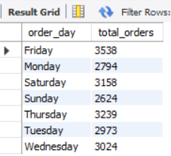

**C. Hourly Trend for Orders**

**SELECT hour(order_time) as Order_hours, count(distinct Order_Id) As Total_Orders**

**From Pizza_Sales**

**Group By Hour(Order_Time)**

**Order By Hour(Order_Time);**

**\*Hour()🡪 To extract hour from order_time**

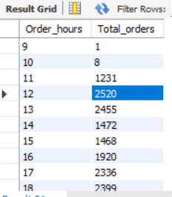

**D. % of Sales by Pizza Category**

**SELECT pizza_category, CAST(SUM(total_price) AS DECIMAL(10,2)) as total_revenue,**

**CAST(SUM(total_price) * 100 / (SELECT SUM(total_price) from pizza_sales) AS DECIMAL(10,2)) AS PCT**

**FROM pizza_sales**

**GROUP BY pizza_category**

**1. SUM(total_price):**

* **This calculates the total sales (revenue) for a specific pizza category (e.g., Veg, Non-Veg).**

**2. (SELECT SUM(total_price) FROM pizza_sales):**

* **This calculates the total sales across all pizza categories (grand total revenue).**

**3. SUM(total_price) * 100 / (SELECT SUM(total_price) FROM pizza_sales):**

* **The specific category's total sales is divided by the grand total, and then multiplied by 100 to convert it into a percentage.**
* **Example:  
  If a category has $200 in sales and the total sales for all categories is $1,000: Percentage=(200/1000)×100=20%**

**Select Pizza_Category, Sum(Total_Price) As Total_Sales ,Sum(Total_Price)*100/(Select Sum(Total_Price) From Pizza_Sales) As Percentage**

**From Pizza_Sales**

**Group By Pizza_Category;**

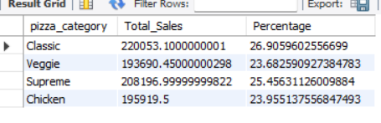

**\*Grand Revenue: (Select Sum(Total_Price) From Pizza_Sales)**

**\*(revenue) for a specific pizza: SUM(total_price)**

* **For January month:**

**SELECT Pizza_Category, Sum(Total_Price) As Total_Sales ,Sum(Total_Price)*100/(Select Sum(Total_Price) From Pizza_Sales Where Month(Order_Date)=1) As Percentage**

**From Pizza_Sales**

**Where Month(Order_Date)=1**

**Group By Pizza_Category;**

**EXCEL FORMULAE**

**=TEXT(order_date, “dddd”) 🡪 dddd – Thursday**

**=1/COUNTIF(B:B,[@[order_id]])**

**Pivot_table_Analyse 🡪 refresh to reflect new changes**